**Name: Antonius Kaharap Kautsar  
Class: 1-I  
NIM: 2341720067**

**Assignment:**

**Practical section 1:**

**Question 1**

**We can see from the output the page display a “Hello world” text**

**Question 2**

**On the console tab in inspect element we can see that it outputted “Saya belajar javascript” Since we used the console.log syntax**

**Question 3  
Because the comments is written to the console logs thanks to the syntax**

**Practical section 2**

**Question 4**

**We have printed the comments from the code we wrote, one thing to note is that we’re able to know which line the statement executed in this case line 8 and line 14**

**Question 5**

**Both are okay to write the script, it all depends on the user preferences and needs.**

**Question 6**

**When we clicked on the link the page will gives us an alert which will display “Yey!” based on the syntax we created which is a link statement**

**Question 7**

**The output of the two program are the same but in the code the first one used the onclick attribute which is the inline way to attach JS code directly to the html, but for the second one we used the javascript: syntax which is apart of the href attribute**

**Question 8**

**We have created a basic html page based on the jobsheet, but when we launched it, it will display the notification alert page based on what we wrote on JS code**

**Question 9**

**It wouldn’t be able to run the JS file because its not on the same directory of our html file unless in the src we specified the path to where the JS file resides in**

**Practical section 3:**

**Question 10**

**We created new function on the code based on the jobsheet and then we called the function using the onload syntax which then will call the function**

**Question 11**

**We created a new JS code in our html code and created a var and a if else statement which will check if the user clicked OK or cancel (Symbolize by the if and else statement) if the user clicked it will redirects to the polinema website. If not, it will write the the following comment to the web page**

**Question 12**

**We just created a JS code in our html file which we then created a variable named nama and then we used the prompt syntax which will ask us for our name and then it will write in the page a paragraph by Hello (nama)**

**Practical section 4:**

**Question 13**

**We created a html page with a JS code based on what was written in the jobsheet. We created 3 variables and then crated an alert notification which will display “Selamat dating di (name)” and then the following 3 document.write statement we just called the 3 variables followed by a comments**

**Practical section 5:**

**Question 14**

**In the html code we created a JS code and within it we created a function named sayHello and the function will use the alert notification with the comments based on the jobsheet. We then called the function in the body specifically in the link which is called on the onclick syntax (it calls the function)**

**Question 15**

**We have created a JS code which is a function named total which will accept 2 variables and then it will return the addition of those 2 variables. We then called the number on the body segment the output which will display the addition of those2 variables in the pages because we called the function using document.write syntax**

**Practical section 6:**

**Question 16**

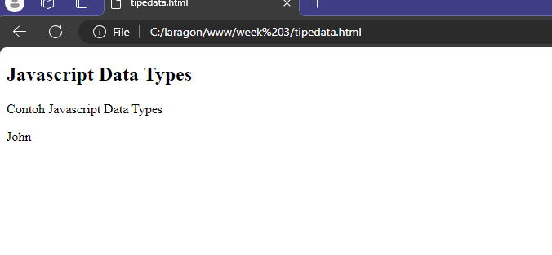

**We created the code based on the jobsheet and then in the script section we created the variable x, the variable x first will be undefined but then we added the 5 value which is an int (number) on to it and then we added the String value of John to it. We then called the demo id and then set its innerHTML to the value of x in thise case is john**

**Question 17**

**Just like previous questions we created a similar JS code however this time we created 3 variables and we set all of their value to String (according the code snippets) and we then use the document.getElementById and look for demo and then set its inner html to the 3 variable we just created.**

**Question 18**

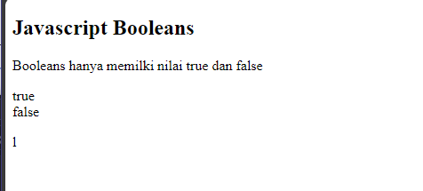

**Just like the previous question too, we created 3 variable but this time with the data type of int, we then again used the document.getElementById to set the inner element of demo and then we ran the comparison operator to check if x is equal to y and x is equal to z the output will display the Boolean value of true and false**

**Question 19**

**This time we created a variable of Array in the script section and in it we used the [] brackets and input 3 String value on it**

**We then used the document.getElementById method so that we can write inside the inner html of the demo id and we printed out the first index of the cars elements which is satu**

**Practical section 7:**

**Question 20**

**Much like before we did the same thing and typed some comments on the paragraph section that doesn’t have a class or id**

**And then in the script section we created 3 variable, x and y variables we set up the value while the z value used the + operator to addition x and y**

**We then printed its value inside the demo id paragraph using the innerHTML syntax**

**Practical section 18:**

**Question 21**

**We created the following HTML code based on the jobsheet and then we created a single variable called totalBelanja which will then launch a prompt thanks to the syntax which ask us how much did we shop**

**And then we created an if statement that checks if totalBelanja is greater than 30k, if it does it will write a header2 with the comment based on the jobsheet if not it will not execute the code inside of the if statement**

**Question 22**

**We created the basic html page again based on the jobsheet and then on the script section we created a variable by the name of password which then will launch a prompt thanks to the prompt syntax that will ask us for our password**

**We also created a if else statement which will check if the password is the same as teh, if yes it will display the Header if not it will display the paragraph.**

**And then lastly it will always display the thank you message.**

**Question 23**

**We created the basic template for the HTML based on the jobsheet and then in the body segment we created a variable called jawab which will asked us to input a number thanks to the prompt syntax and then we created a switch case statement which will give us different answer depending on which number we picked from 1 to 5 if we picked other number from 1 to 5 it will default to the wrong selection comments**

**We also created a if else statement that checks if the hadiah value is empty or not if it is it will said that we failed to get the present if it not empty it will display the comment with the following hadiah variable presented as a header2, it will display the output on the paragraph that has the id of demo**

**Question 24**

**Per usual we created the basic HTML template and inside the body we created 2 variable named username and password which both uses the prompt syntax that will ask us on our username and password**

**And then we created a nested if else that first will check if user username is correct if not it will say we’re not registered and in the nested if else it will check if the password is correct if not it will display the comment that our password is incorrect**

**Practical section 9**

**Question 25**

**We first created the HTML template page and then in the body segment we created the script section which we first created 2 variable called text and i, text is a empty variable while i for now is also empty too. We then created an loop which will set the i to an int data type and check if its less than 5 and it will add the number by 1 per loop.**

**Inside the loop we added the value of text to the following comment it will also display the i variable, it will continue to loop until i has reached 5**

**It will print the output inside of the paragraph that has the id of demo**

**Question 26**

**Per usual we created the template HTML and then in the body segment we created a script and we first created 2 variable with a empty String and int data types and then we created a while statement which will check if i is lesser than 10 and inside it we set the text value to the following comment + i and then i will get increased incrementally**

**Question 27**

**As usual we created the base HTML and then in the body segment we created a script and inside of it we created 2 variable with String and int data types and then we created a do while statement, inside the do we first set up the text to the comment on the jobsheet + i and then we incrementally increased the value of i by 1 then to make sure it loops outside of the do curly brackets we created the while with it checking if i is lesser than 10 to make sure it loops. It will then print the value inside of the paragraph that has the id demo**

**Github link : https://github.com/Valtern/week-3**